Science Supplies for Ms. Burris
- Science binder for ONLY science materials
(approx. 1 inch. Label with first & last name and subject)
- Notebook (Label with first & last name and subject)
- Pencils
- Assignment (if you had one)

Ms. Burris Needs Donations
“PRETTY PLEASE…”
Top Priority Donations Needed
- Facial Tissue
- Hand Sanitizer
- Counter wipes
- Zip-style baggies (sandwich or gallon size).
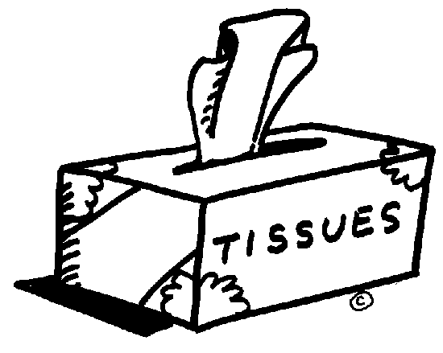
We seem to use a lot of these in science.

Donations that are just a little extra, but also extra appreciated!
- Band-aids  - Tape (disposable single dispenser)  - Pencils  - Baby Wipes/ Clorox wipes  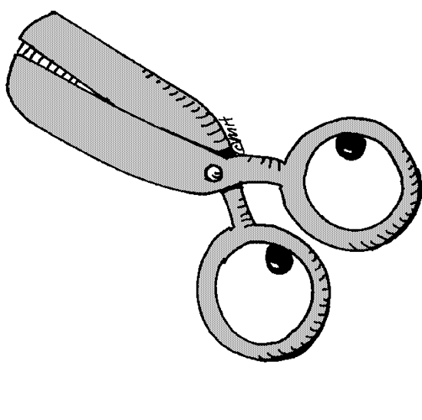  - Sharpie Markers (black)  - Eraser caps  - Pink erasers  - Scissors (ours have disappeared!) | - Dish soap  - Markers  - Crayons  - Colored pencils  - Glue Sticks  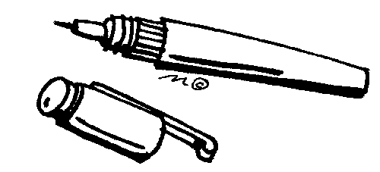  - Rolls of paper towels  - Bird seed for our class bird feeder

